**Super market**

For this task we use

Frontend application development in Angular 12

Backend REST API development in Dot net core.

**Landing page**

**Shopping**

1. In this section user can see the categories wise item list.

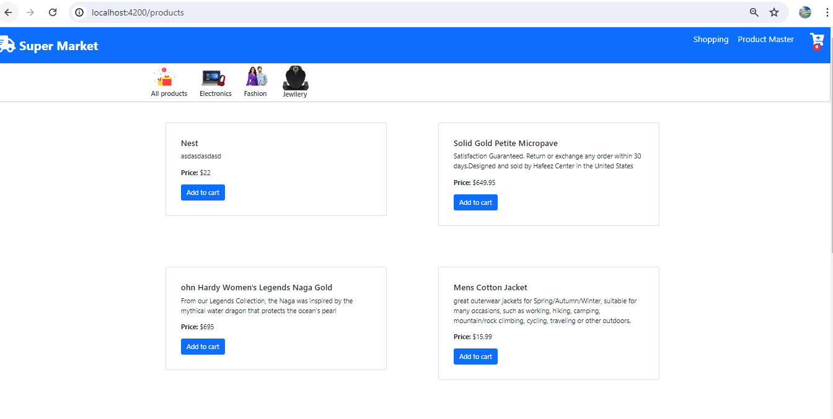

2 User can select/add the multiple items into cart.

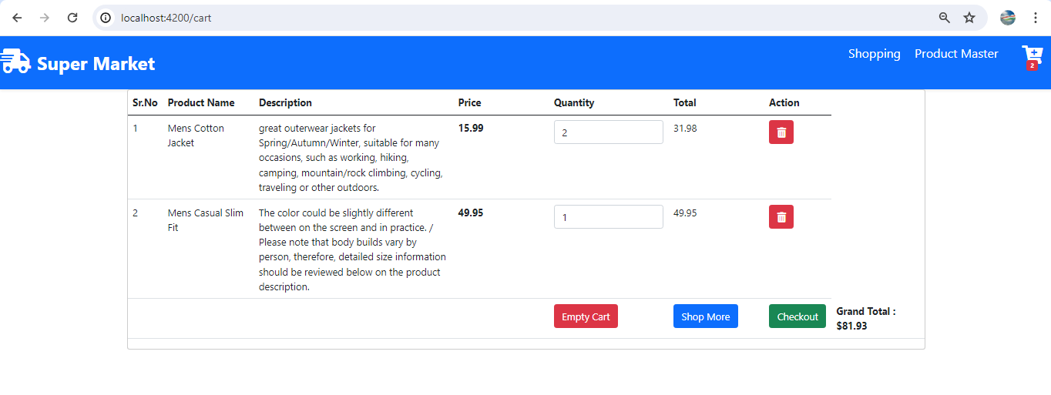

3. User can enter the quantity and automatically update the total and Grand total of item. Also delete the item from cart.

**Product Master** –

In this section user can add /update / delete the products.

**1.Listing page** -User can see the list of product

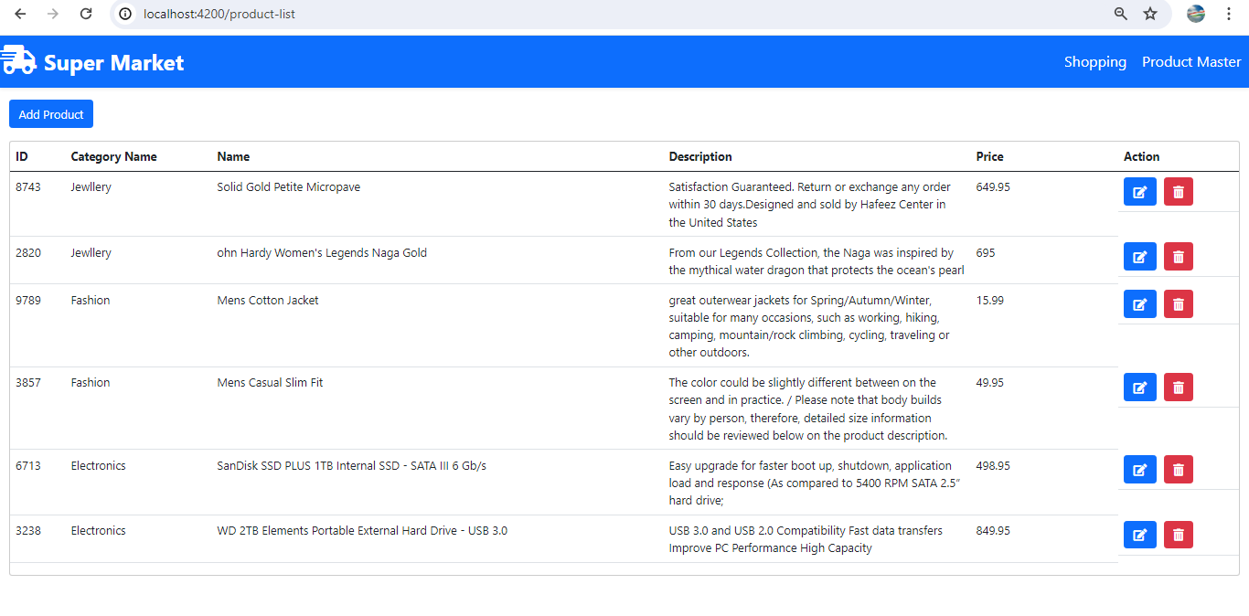

**2.Add Product**

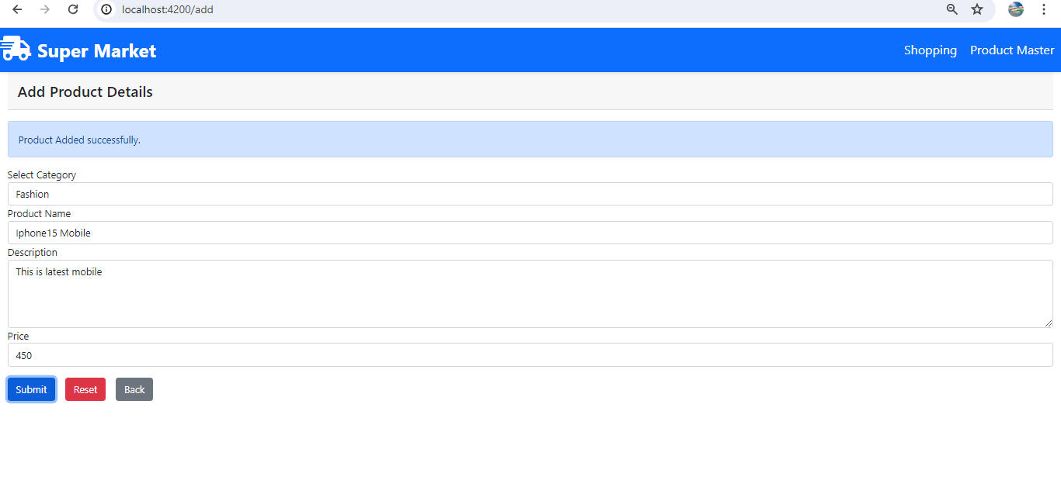

**3.Update Product**

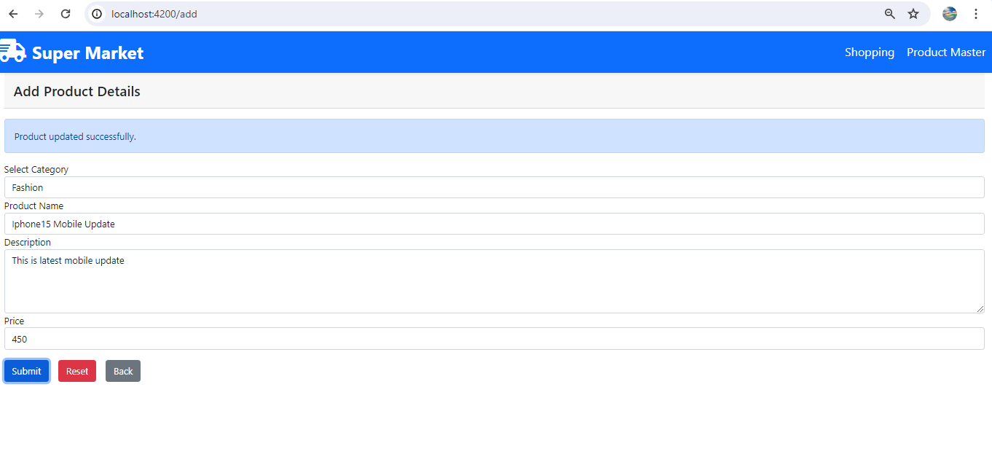

**Give an overview of the code & explain the key elements.**

**Angular application -**

We have created below component to manage the application

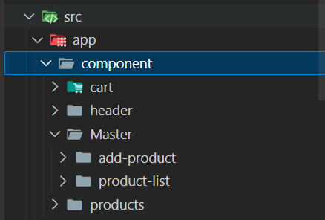

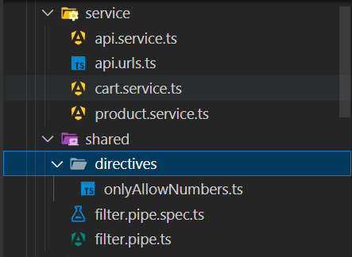

Api service.ts - To handle the api calls Like

GET ,POST, PUT,DELETE and also handle the error.

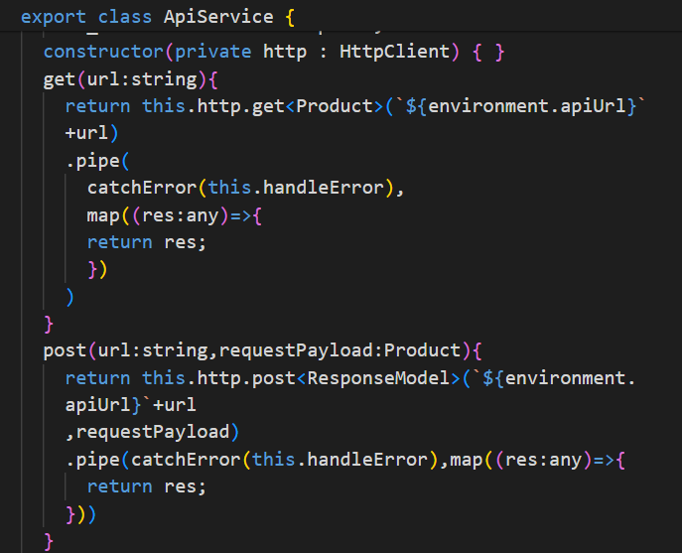

Api.urls.ts – To handle all REST api Urls or constants

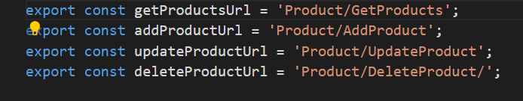

Cart.service.ts – To handle to cart functionality like storing /removing data into cart with the help of BehaviorSubject

Product.service.ts - To handle to product functionality – pass data from list page to details page.

Directives –

onlyAllowNumbers – This directive is use for cart quantity text box –use can enter only valid data.

FiltersPipe –This pipe use for -getting the categories wise data on shopping page.

**REST Dot Net core API** –

We have created 4 api to manage the application

